**More String Formatting**

There is also another way to format strings using the *"{}".format(variable)* form. Here is an example: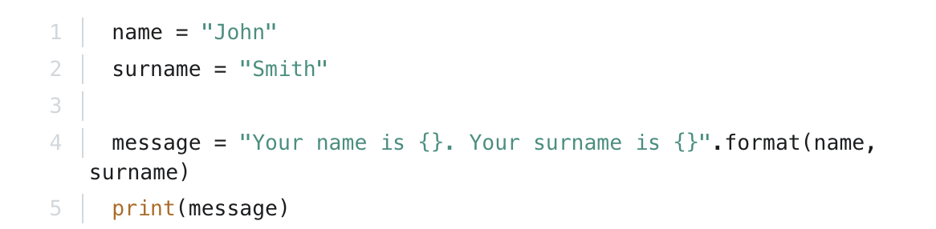

Output: *Your name is John. Your surname is Smith*